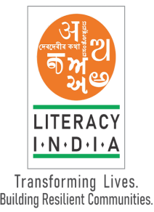litracy

Limited Seats

Register Now

[**www.litracyindia.org**](http://www.litracyindia.org)

**Session Start From**

**January 2024**

**Contact no- 8588853380**

**PROGRAMS OFFERED**

* Robotics/ Tinkering
* Computer Hardware
* Mobile Repairing
* Cooking/ Hospitality
* Beauty & Wellness
* Stitching & Cutting
* Electrical Troubleshooting
* Two-wheeler Repairing
* Mobile Journalism
* Computer Science
* Call Centre/ BPO
* Logistics
* Data Digitization
* Natural Farming Market Connect
* Banking

Literacy India Community College (LICC)